D9930 DISTRICT GRANTS GUIDELINES 2026-27

What is a district grant?
A district grant is a ‘bulk fund’ allocated to the district from The Rotary Foundation (TRF), which the district then manages in terms of the projects and activities it is used to support. The district grant application submitted to TRF by the district is an aggregation of the district grant proposals received from clubs for that year.

Terminology
District Designated Funds (DDF) 50% of the all the funds the district contributed to TRF Annual Fund are returned to the district three years later in the form of DDF
District Grant (district) The bulk amount the district requests from TRF each year. districts can use up to 50% of the District Designated Funds (DDF) for district grants
District Grant (club)– The grant each club can apply for each year to support for various projects and activities. Clubs need to meet various criteria to ‘qualify’ for a district (or global) grant

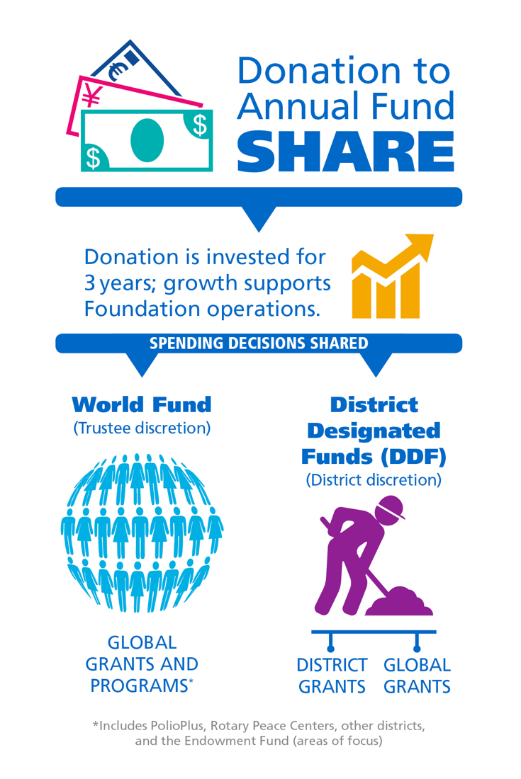
Requirements
Clubs district grants are managed by the district Rotary Foundation Committee and specifically by the grants sub-committee. Key aspects of projects and activities funded by district grants are that they:
- must support the mission of TRF which is to enable Rotarians to advance world understanding, goodwill, and peace through the improvement of health, the support of education, enhancing environmental sustainability and the alleviation of poverty
- can have an immediate/short term impact – i.e., they do not need to demonstrate sustainability/long-term impact in the way that a global grant has to
- can take place within district 9930 or outside of the district (including international)
- can support scholars locally or internationally they can fund Rotary youth programmes e.g. RYLA, RYPEN
- generally requires active involvement of Rotarians

Use of Funds
Subject to the Terms and Conditions for Rotary Foundation District Grants, district grant funds can be used in club projects for local and international humanitarian and service projects including:
- Local or international service projects and related travel
- Scholarships for any educational level
- Vocational training teams (groups of professionals who teach others about a particular field or learn more about their own) and related travel
- Rotary Youth Exchange, RYLA, Rotary Friendship Exchange, Rotaract, or Interact programmes
- Community assessments for global grant projects
- Construction (e.g. toilet blocks) and renovation
The minimum grant will be $500 and the maximum grant will be $5,000 per club except that in an exceptional circumstance and where there is sufficient funding to do so the grants sub-committee may recommend a larger grant.

Requirements of a district grant application
- For district grants, the district also establishes its own processes and requirements. district 9930 has determined that the district will apply to TRF for the full 50% of DDF as a district grant providing it receives proposals from the clubs up to that amount.
- It is strongly advised that presidents’ elect attend District Training Assembly and the President Elect Training Seminar (PETS)
- Before the Grants Sub-committee will consider a club’s grant proposal, the club must be qualified to submit grant application i.e. the club:
  - has at least one member who has completed the online Grants Management Seminar or Recertification course and attended the D9930 Grants Webinar
  - has signed the club MOU
  - has entered their TRF goals for 2026-27 on Rotary Club Central by 31st August 2026
  - is up-to-date with district and Rotary International dues
  - is up-to-date with reporting on any previous grants; and
  - has a club president appointed for each Rotary year that the project covers
- The club must operate a bank account or sub account for the receipt and spending of the district grant funds in such a way that it can clearly track and report on all income and expenditure relating to the grant-funded project. Copies of the club bank statements clearly identifying the district grant money in and project related disbursements out will need to be supplied with the reports along with receipts, invoices or other evidence of all expenditure
- Clubs may (and are encouraged to) group together to apply for a district grant
- A club may only submit one grant proposal each year (or be part of one combined proposal)
- Clubs will be required to contribute funds (cash) into the project of at least an equal amount to that being requested from the district grant fund
- Non-Rotary organisations (‘cooperating organisations’) may also be involved in projects. Funding from them must be itemised in the proposal. Clubs should take care to ensure that the requirements of any other organisations involved in the project – in particular city or district councils (e.g. resource consents), are carefully planned for and managed
- While it is common and appreciated when donations in kind (DIK) from member’s businesses or other organisations enable a project to be carried out, please be aware that DIK of goods or time cannot be costed into the project budget as actual or ‘cash’ costs as this would essentially result in the club retaining grant funds. he reporting and presentation of receipts and other evidence of expenditure must demonstrate real/actual expenditure excluding DIK
- Where the total amount of district grant funds requested by clubs exceeds the funds available the Grants Sub-committee will decide on the distribution of those funds. Recommendations will be made according to the D9930 judging criteria checklist
- Each year one or two grants finalised in the previous year will be randomly selected for audit by the district Foundation Stewardship Chair. If your club grant is selected, your club officers are expected to co-operate with the production of all records associated with the grant as requested by the Auditor

Reporting
- The club must submit an interim report to the Grants Sub-committee three months after receipt of the district grant funds and every six months thereafter while the project is continuing. The interim reports are to set out project progress and actual and future expenses against the original budget
- Where the project looks likely to extend beyond the intended date for completion, the club must report that as soon as possible
- A final report is required within two months of the completion of the project to the Grants Sub-committee. The final report is to provide actual expenditures against budget along with photos and media coverage and will trigger the payment of the final 50% of the grant
- It is expected that most projects will be completed within the current Rotary year. All projects and activities funded by the district grant must be completed within 24 months of the club receiving the funds from district.
- A standard reporting format will be provided. Clubs will be required to retain all documentation relating to the project as per the Club MOU. Bank statements and invoices/receipts are required with all reports. Please refer to D9930 District Grants Timeline
- In accepting a grant, clubs are making a commitment to meeting the reporting deadlines associated with that grant
- When the project is completed and all reports have been lodged with district, the remaining 50% of funds will be disbursed
- Assuming that there are no issues with the district’s District Grant application to TRF, approval should only take a few days and the funds arrive very soon after that. However, if TRF have questions relating to the spending plan (club projects) or there are a lot of grant proposals submitted to them at the same time, the process may be slower

Further resources
- D9930 Rotary Foundation Grants: how to apply
- R.I. District Grants website

If you have any questions regarding district grants, please contact:
District Grants Chair, Pat Taylor
patandbernienz@gmail.com
027 34 77657

